Wildcard Generics
<?>
means any data type
<? extends juice>
means any data type extends from juice data type(lower bounded wildcard)
<? super juice>
meas any data type in the super class or higher hierarchy of juice class(higher bounded wildcard)?
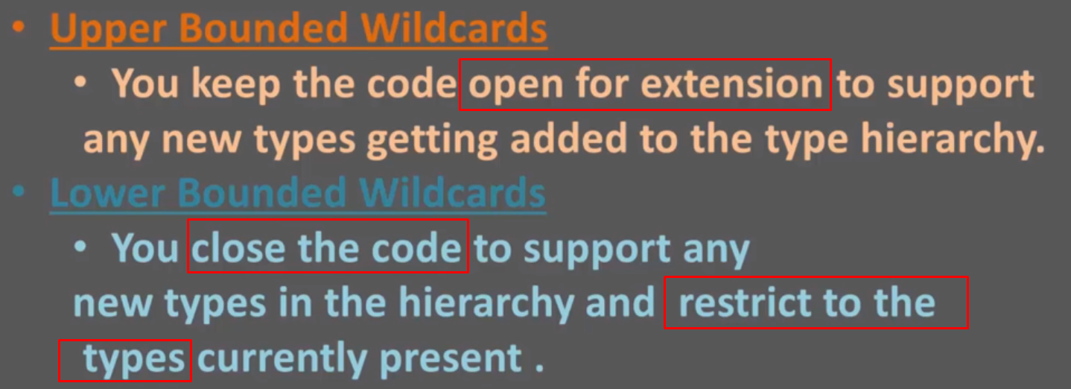

Generics inheritance and subclass
Generics also have inheritance hierarchy like classes

the blue statement is wrong because it’s different data type although they have class inheritance relationship.
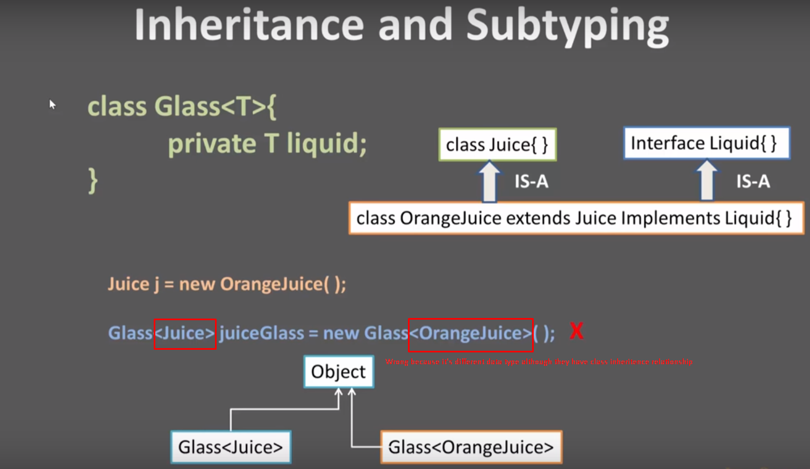

Collection and Generics
Collection is a wrapped Interface since Java version 1.2 and it’s data type is ArrayList
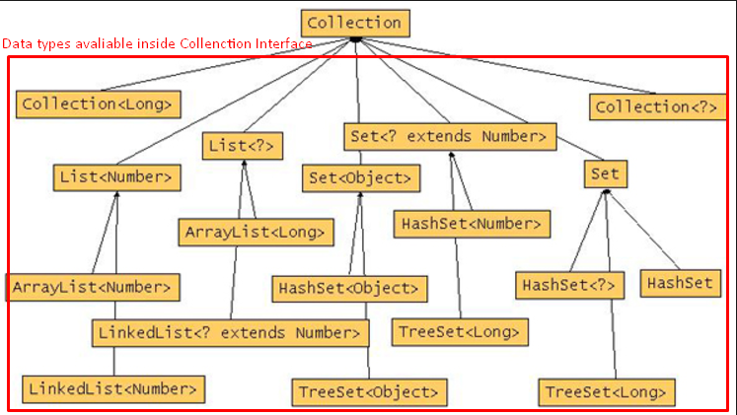

Generics = Type parameter 泛式就是类型参数化
定义泛型的意义：achieve type safety when using API
例:
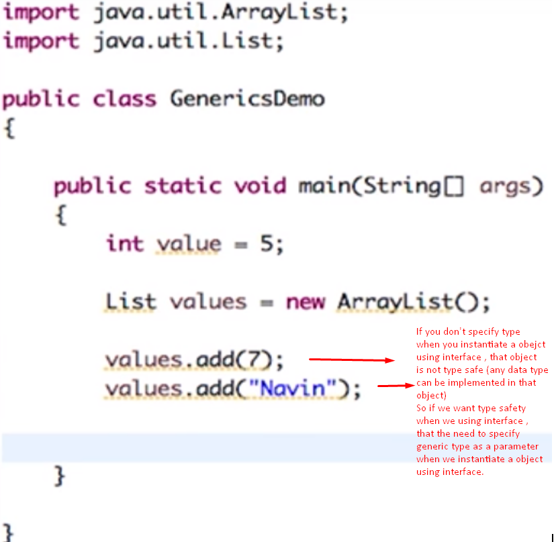

泛型：自主定义数据类型的方法

类、方法、接口的设计都可以使用泛型，java可以灵活地构造和运用泛型。
泛型设计允许程序员在强类型程序设计语言中编写代码时定义一些可变部分

泛型字母缩写：
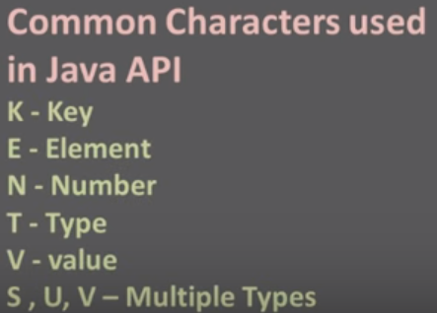
泛型类实例化:
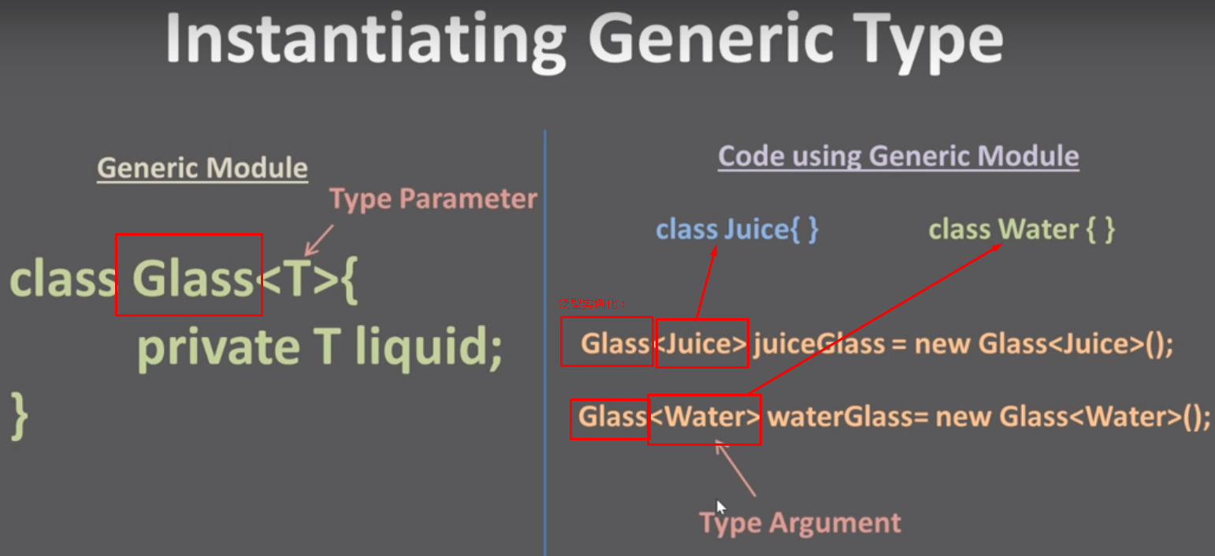
泛型类声明的语法要求:
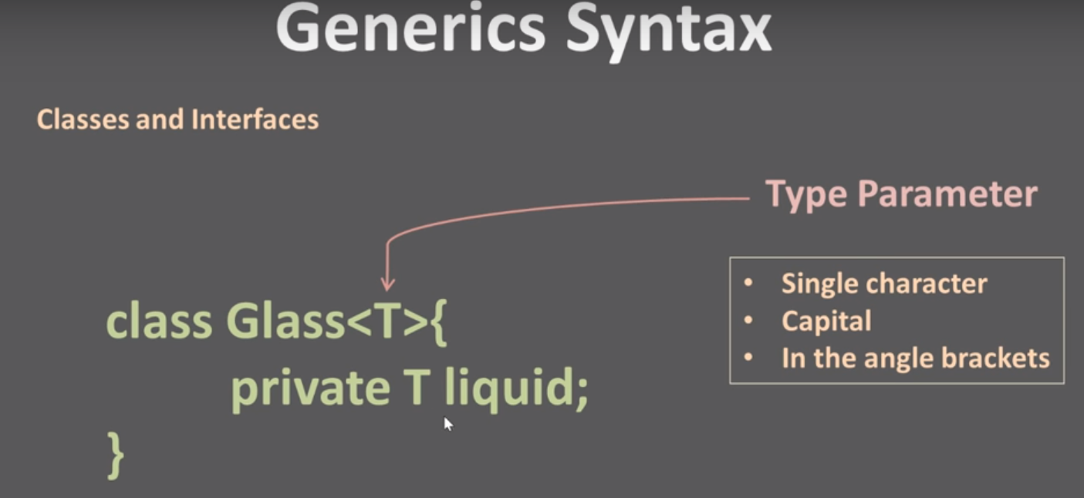

Static language VS Dynamic language
static language(C C++ Java)

dynamic language(python javascript ...scripting language)

